**What is Business Analytics Process and explain the necessary steps in the Business Analytics Lifecycle**

* The **Business Analytics Process** is a step-by-step method that companies use to solve business problems using data.
* It helps organizations to collect data, analyze it, and make smart decisions that improve performance, increase profits, or solve issues.
* This process is also known as the **Business Analytics Lifecycle**, and it includes several important steps—from understanding the problem to taking action and checking results.

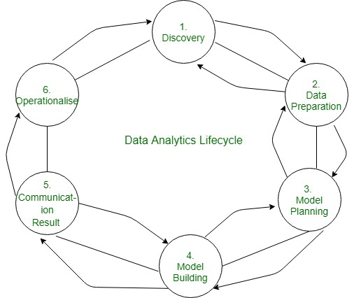

**1. Discovery (Discover)**

This is the **first step**, where we try to understand the business problem and what kind of data and tools we’ll need.

**What happens in this step?**

1. **Understand the Business Goal:**  
   Meet with business stakeholders to clearly define what they want to achieve—like improving customer satisfaction or reducing costs.
2. **Identify the Problem Statement:**  
   Narrow down the problem. For example, “Why are sales dropping in the north region?”
3. **Check Available Resources:**  
   Look into what data, tools, and time are available. Also, check if you need new tools or training.
4. **Decide the Project Scope:**  
   Set boundaries for the project. What will be included? What will not? This avoids confusion later.
5. **Form the Team:**  
   Assign roles to analysts, data engineers, and domain experts to begin the work in an organized way.

**2. Data Preparation**

This step is about collecting the raw data, cleaning it, and getting it ready for analysis or modeling.

**What happens in this step?**

1. **Collect the Data:**  
   Get the required data from databases, spreadsheets, cloud storage, or APIs.
2. **Clean the Data:**  
   Fix or remove missing values, duplicates, spelling errors, and incorrect entries.
3. **Transform and Organize:**  
   Convert the data into a consistent format. For example, ensure all dates follow one format (like DD-MM-YYYY).
4. **Combine Data Sources:**  
   Merge data from different sources—such as combining customer info from a CRM with purchase records.
5. **Feature Engineering:**  
   Create new variables that help in analysis. For example, calculate “Customer Age” from “Date of Birth.”

**3. Model Planning**

In this stage, we choose the right **analytical technique or algorithm** to solve the problem.

**What happens in this step?**

1. **Select the Modeling Approach:**  
   Choose whether to use statistical methods, machine learning, or simple trend analysis.
2. **Understand Relationships:**  
   Identify how variables relate to each other. For example, does advertising increase sales?
3. **Choose Tools and Techniques:**  
   Decide whether to use Python, R, Excel, SQL, or other software based on your data and goals.
4. **Split the Data:**  
   Divide the data into training and testing sets so that you can train a model and later test its accuracy.
5. **Design the Model Framework:**  
   Plan how the model will work—for example, what inputs will it take and what outputs will it give.

**4. Model Building**

Now the actual machine learning or statistical model is created and tested.

**What happens in this step?**

1. **Train the Model:**  
   Use the training data to teach the model how to recognize patterns or make predictions.
2. **Test the Model:**  
   Use test data to see how well the model performs and whether it gives accurate results.
3. **Tune the Parameters:**  
   Adjust settings (like learning rate, depth of tree, etc.) to improve the model’s performance.
4. **Validate the Model:**  
   Check whether the model gives consistent and reliable results. Avoid overfitting or underfitting.
5. **Compare Multiple Models:**  
   Build more than one model (e.g., decision tree, logistic regression, random forest) and pick the best.

**5. Communicate Results**

After building a good model, it’s important to share the findings with decision-makers in a simple way.

**What happens in this step?**

1. **Create Visual Reports:**  
   Use charts, dashboards, and graphs to explain the results of the analysis clearly.
2. **Summarize Key Insights:**  
   Write down the most important takeaways in simple language. For example, “High-value customers tend to buy more during weekends.”
3. **Explain Model Performance:**  
   Show how accurate the model is and what it can and cannot do.
4. **Provide Actionable Suggestions:**  
   Turn the data into actions—like “Target customers aged 25–35 in online ads.”
5. **Use Storytelling:**  
   Tell a simple story about the data—what happened, why it happened, and what should be done next.

**6. Operationalize (Deploy the Model)**

In the final step, the model or analysis is put into real business use.

**What happens in this step?**

1. **Deploy the Model:**  
   Integrate the model into real business systems—like websites, CRM software, or mobile apps.
2. **Monitor the Model:**  
   Keep checking if the model is working correctly in the real world. Track performance and accuracy.
3. **Retrain if Needed:**  
   If the model starts performing poorly, update it with new data and retrain it.
4. **Support Business Decisions:**  
   Ensure the model helps the business in real-time decisions—like recommending products to users.
5. **Document Everything:**  
   Keep a record of how the model works, what data it uses, and how to maintain it.